Homework PACKET 5

iDAHO pUBLIC dRIVER eDUCATION

Lane Changes, Passing, & Parking

LANE CHANGES
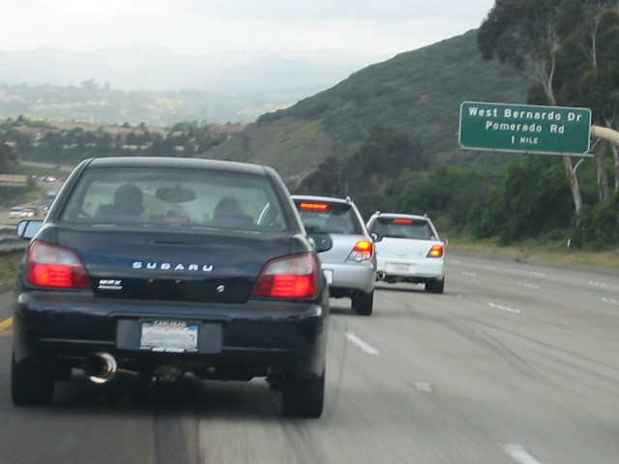

Drivers need to be able to change lanes smoothly and safely – to get over before needing to make a turn, to get around a slow-moving vehicle, or to avoid an obstacle in the road. Regardless of the reason for a lane change the technique is the same: SMOG. Signal, check your mirrors, look over your shoulder, and go when it is clear.

But what if it is NOT clear? Do you cancel your signal? The answer depends on how badly you need to get over. If traffic is bumper-to-bumper and no one seems to want to let you in and you don’t need to change lanes immediately, perhaps canceling your signal and trying again further down the road is wise. But in most circumstances you will want to keep your signal on and continue to check your blind spot for indication that another driver is willing to allow you in front of him. Be patient but do not slow down too much or stop in your lane; traffic behind you expects to continue moving at the posted speed limit.

One of the most challenging parts of a lane change is the quick blind spot check over your shoulder. For that short moment of
time you are not looking at the road ahead of you. Make sure you are at least three (3) seconds behind the vehicle in front of you and that it is not slowing or stopping. Then do SMOG and start making quick glances over your shoulder – checking your front zone between each glance. (And don’t forget your rear zone where traffic may get closer as you slow slightly.) When you are confident the gap is large enough for your vehicle and that any vehicles in that lane are aware of your lane change, slide over, cancel your signal, and adjust your speed and lane position again.

PASSING

Passing another vehicle is a dangerous maneuver and most driver education programs will not risk practicing it. And honestly, when is a driver ed. car going faster than other traffic and need to make a pass anyway?

Passing other vehicles is a safe maneuver on multi-lane freeways where you can do a left lane change, pass a vehicle, and return to the right lane. But on a two-lane highway with on-coming traffic, windy roads, and uncertain road surfaces, it is very risky. And saving a few minutes over a period of hours is simply not worth the risk of a head-on collision or other crash.

One thing all drivers can do to help the flow of traffic is travel in the right lane whenever possible. This is Idaho law anyway and allows faster-moving traffic to pass on the left.

You cannot speed in order to pass another vehicle.

HOMEWORK PACKET 5

Idaho public driver education

on the inside of their windshield to help line up with something outside of the vehicle.
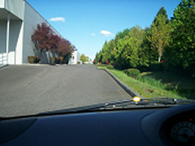
This round sticker tells the driver to line the sticker up with the curb to ensure the wheels will be about one foot from the curb, as shown below.
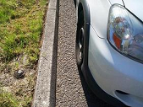

By using reference points when parking at a curb, in an angled or perpendicular stall, or when parallel parking, you will be able to protect your car front dents and dings. It will also be easier for yourself and others to get in and out of the vehicle.

Idaho law requires that you park 18” or less from the curb or edge of the roadway.
PARKING

Parking a vehicle requires speed and steering control as well as good judgment. Parking spaces are small and parking lots are often crowded with vehicles, pedestrians, and shopping carts. When average-sized cars are parked side by side in typical parking spaces there is not even enough room for either car to open their doors fully.

What happens when large trucks park in those same spaces?

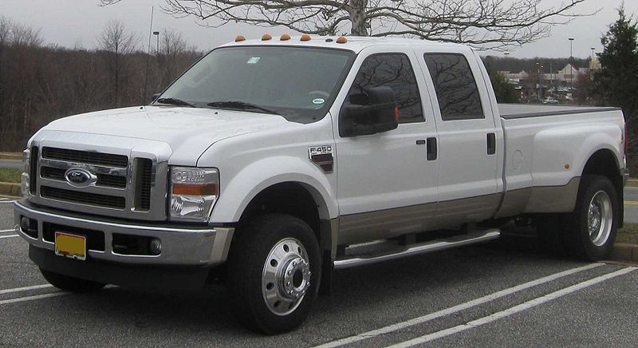

Sometimes parking can get pretty tight!
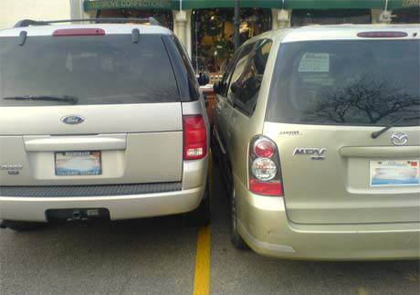

Many drivers use reference points to help position a vehicle in a parking space and to make sure there is as much room on both sides of the vehicle as possible. A typical reference point is something that is on all vehicles, like a hood ornament, side mirror, or windshield wiper. Some drivers even go as far as putting small pieces of tape
REVIEW QUESTIONS
HOMEWORK PACKET 5

NAME: _______________________________________ DATE: ____________

DIRECTIONS: Answer the following questions based on what you learned from the homework packet.

- If you need to make a lane change but traffic is heavy, what should you do?
- SMOG stands for:
S
M
O
G
- When you are preparing to make a lane change, how much should you slow down?
- How do you prevent the car from wandering while you look over your shoulder to check your blind spot?
- How can you use a reference point to help you park?

