Homework PACKET 7

iDAHO pUBLIC dRIVER eDUCATION

Sharing the Road with Others

MOTORCYCLES
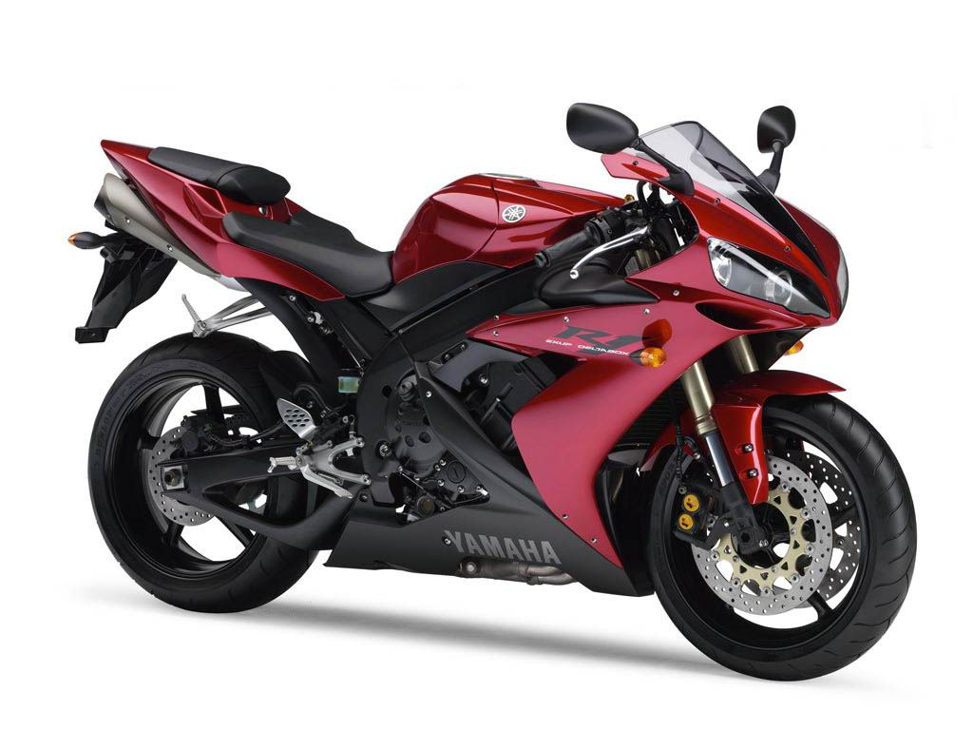
Riders at Risk!
Even with good riding gear and a helmet, motorcycle riders are exposed to the weather, road conditions, other vehicles, and the asphalt. In addition, they do not have the protection of air bags, seatbelts, crumple zones, bumpers, or the heavy frame of a car or truck around him. Any crash where a rider is involved is very likely to result in injury (or worse). You DON’T want to be the driver who has to live with the knowledge that they caused that injury.

Left Turns and Blind Spots:
Motorcycles are small, have only one headlight, and often seem further away than they really are. When you plan to turn left across one or more lanes of traffic or change lanes always look for motorcycles that may be in your path. Do careful blind spot checks for every lane change even if your mirrors show that it’s clear!

Turn Signals and Tailgating:
If a motorcycle has its turn signal on do not assume it is turning. It could simply be that the signal is still on from a previous turn. Most motorcycle turn signals do not self-cancel.

If a motorcyclist is tailgating you, avoid sudden braking that could cause the motorcycle to hit your back end. The best thing you can do is increase your following distance behind any vehicle in front of you. This could help prevent you from having to brake suddenly.

Check behind you frequently – a motorcycle may be preparing to pass you.

Riding – More Challenging than Driving:
Riding a motorcycle is much more challenging than driving a car or truck in many ways. They are light but can be very powerful. They have two wheels so are less balanced. They have separate front wheel and rear wheel brakes. The clutch is operated by the left hand and the rider shifts gears with the left foot. Turning requires different techniques at low speed than it does at higher speeds. Careful coordination of all these controls and techniques is required to ride safely.

All riders in Idaho under the age of 21 must wear a helmet while riding.

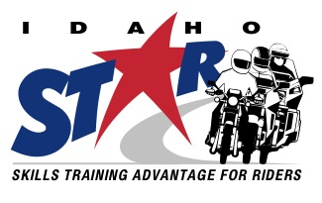

Rider Training – the Way to Go:
Taking a rider training course offered by Idaho STAR is highly recommended for riders of all ages and abilities. In fact, crash data show that Idaho STAR training is associated with a substantially reduced crash risk. All riders under the age of 21 are required to take a rider training course and there are courses for all ability levels. Visit http://idahostar.org or call 888-280-7827 to learn more!

HOMEWORK PACKET 7

Idaho public driver education

No Zone
No Zone
No Zone
No Zone
Large trucks, like RVs, require more room in their lane, more room to turn, and more time to stop. Drivers should be aware of these requirements and be cautious. When a large trucks turns right it needs to swing wide first, often looking like it is going straight, before cutting sharply right. Small cars and trucks, like the one below, often get caught by surprise by these “wide right turns” if they are not paying attention.

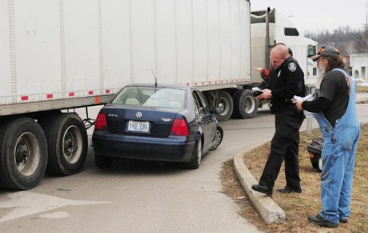

When driving beside or behind a large truck it is important to avoid the “No Zone”. This is the large blind area around a truck that the driver cannot see. The easiest thing to remember is that if you cannot see the truck driver’s eyes he cannot see you either.
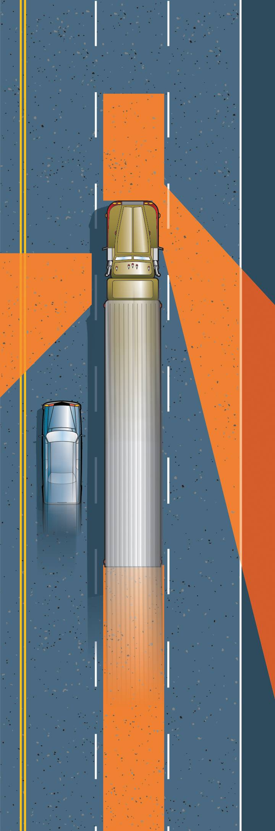
TRUCKS AND OTHER LARGE VEHICLES

Recreational vehicles (RVs) are more common in summer months on highways and freeways around the state. These vehicles are slow, large, and heavy, requiring drivers to be aware as they approach one. Give them room and expect their speed to be less than the posted speed limit, especially on steep hills.

School Busses are carrying our most unpredictable pedestrians: school children. Always be cautious around school busses and know when the law requires you to stop for one that is loading or unloading students.

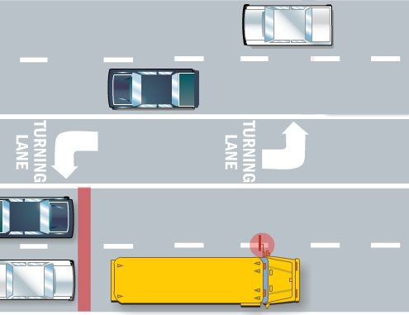

Vehicles behind a stopped school bus that is loading or unloading students must always stop. Opposing traffic only needs to stop is there are fewer than two lanes on both side of the road (four total).

Emergency vehicles traveling in either direction with their lights flashing or siren sounding require all drivers to pull as far to the right side of the road as possible and stop. Once the emergency vehicles have passed the drivers may continue.

HOMEWORK PACKET 7

Idaho Public Driver Education
BICYCLES

In Idaho, bicycle riders have the same rights and responsibilities as motorized vehicles.

If bike riders can keep up with the flow of traffic they are allowed the share traffic lanes with vehicles. If they cannot maintain the speed limit they must ride as far to the right side of the road as safely possible.

Riders must ride in the same direction traffic is moving.

Bike riders in Idaho do not have to stop for a stop sign and can continue moving if they have the right of way. Riders also can proceed at a red light after stopping and making sure they have the right of way.

Drivers wanting to pass a bicycle should begin the passing procedure well behind the cyclist and give them as much room as possible. Move to lane position 2 or do a lane change if possible before returning to your lane.

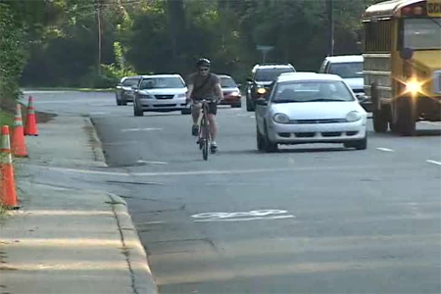

For more information on Idaho’s bicycle safety program, call 334-8272.
PEDESTRIANS

About 12% of all traffic deaths in Idaho involve a pedestrian. When driving a vehicle, be aware of pedestrian activity, especially near residential areas, schools, school crossings, bus stops, playgrounds, and parks.

Use the IPDE process to IDENTIFY pedestrians in the area and PREDICT any possible conflicts. If the pedestrians are young children, expect the unexpected as they often dart into the street without any thought to the consequences.

But older pedestrians can be a hazard as well, busily talking or texting on a cell phone and not paying attention. Elderly pedestrians may not be able to see or hear as well and you should PREDICT that they may not see or yield to you.
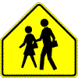

Parking lots can be dangerous because of the high number of vehicles parked closely together. Pedestrians, especially children and short adults, are difficult to see as they walk behind and between parked vehicles. Be extra cautious when backing out.

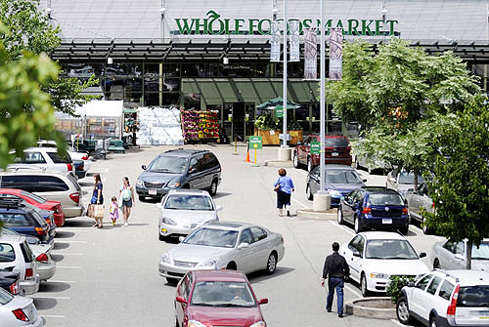

REVIEW QUESTIONS
HOMEWORK PACKET 7

NAME: _______________________________________ DATE: ____________

DIRECTIONS: Answer the following questions based on what you learned from the homework packet and chapter 5 in the Idaho Drivers Manual.

- Cars turning _____ in front of an oncoming motorcycle cause most of the serious car/motorcycle crashes in Idaho.
- When a motorcycle is tailgating you, the best thing you can do is increase _____ following distance behind any vehicle in front of you.
- Name three ways that a motorcycle rider is not as protected as a vehicle driver or passenger.
- At your age, if you wanted to ride a motorcycle, what two things are required?
- If you are approaching the front of a school bus stopped loading or unloading children, how do you know if you have to stop?
- Large trucks make wide ______ turns.
- The blind areas around large trucks you should avoid are called the ___________.
- About ___% of traffic deaths in Idaho each year involve a ____________.
- Which way do bike riders have to ride – with or against the flow of traffic?
- What laws in Idaho are unique to bike riders?

